**ASSIGNMENT**

**I**

**Fundamentals of Computer programming**

**Prepared by: <NAME>**

**BscCSIT**

1. **Write an algorithm and flowchart to display Sum of two numbers**

**Algorithm:**

Step 1: Start

Step 2: Declare variables num1, num2 and sum=0.

Step 3: Read values num1 and num2.

Step 4: Add num1 and num2 and assign the result to sum.

sum = num1+num2

Step 5: Display sum

Step 6: Stop

**Flowchart:**

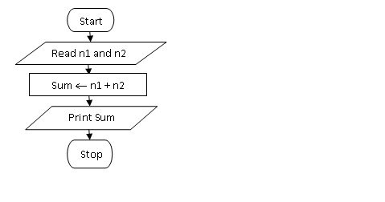

1. Write an algorithm and flowchart to display if the number is positive or negative

**Algorithm**

Step 1: Start

Step 2: Enter any number n

Step 3: check the entered number if n >0

Then display number n is positive

If n is less than 0 (n<0)

The display number is negative

Else

Display number is zero

Step 4: Stop

**Flowchart:**

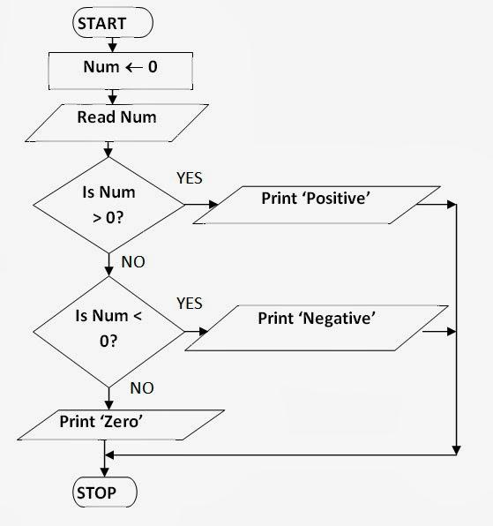

1. Write an algorithm and flowchart to display whether the number is even or odd.

**Algorithm:**

Step 1: Start

Step 2: Read a number n

Step 3: Divide a number n by 2 and store the remainder in **num** variable

Step 4: check if num is equal to zero then display the number is even

else display the number is odd

Step 5: Stop

**Flowchart:**

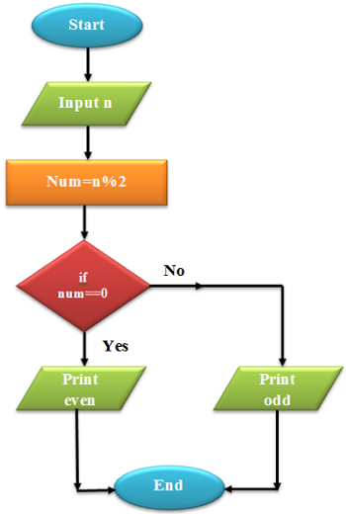

1. Write an algorithm and flowchart to read three numbers and print the greatest number.

**Algorithm:**

Step 1: Start  
Step 2: Declare variables a,b and c.  
Step 3: Read variables a,b and c.  
Step 4: If a>b  
 If a>c  
 Display a is the largest number.  
 Else  
 Display c is the largest number.  
 Else  
 If b>c  
 Display b is the largest number.  
 Else  
 Display c is the greatest number.   
Step 5: Stop

**Flowchart:**

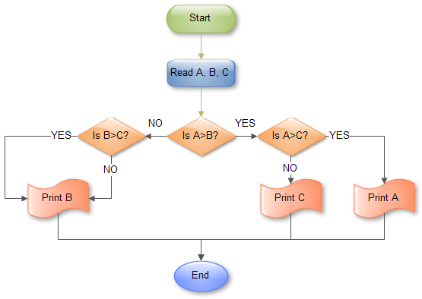

1. Write an algorithm and flowchart to find the sum of the series 1+2+3+4….. Up to entered n numbers.

**Algorithm:**

step 1. Start

step 2. initialize i=0, sum =0 and n

step 3. Read the input value n

step 4. check if i < n-1

if yes then sum =sum+1 and go to step 5

else print sum and goto step 6

Step 5. i=i+1 and go to step 4

Step 6. Stop

**Flowchart:**

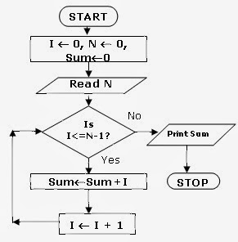

1. Write an algorithm and flowchart to display factorial of a given number N

**Algorithm:**

Step 1: Start  
Step 2: Declare variables n,factorial and i.  
Step 3: Initialize variables  
 factorial←1  
 i←1  
Step 4: Read value of n  
Step 5: Repeat the steps until i=n  
 5.1: factorial←factorial*i  
 5.2: i←i+1  
Step 6: Display factorial  
Step 7: Stop

**Flowchart:**

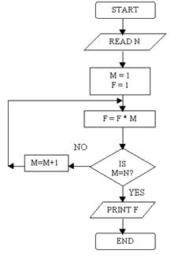

1. Write an algorithm and flowchart to read first 20 number and display only sum of even numbers.

**Algorithm:**

Step 1 : Start

Step 2 : Initialize sum=0 and count =1

Step 3: check if count is an even number

if yes sum= sum+1 and go to step 4

else got to step 4

step 4: count =count +1

Step 5: check if count is greater than 20 if yes go to step 6 else go to step 3

step 6: display the sum

step 7: Stop

**Flowchart:**

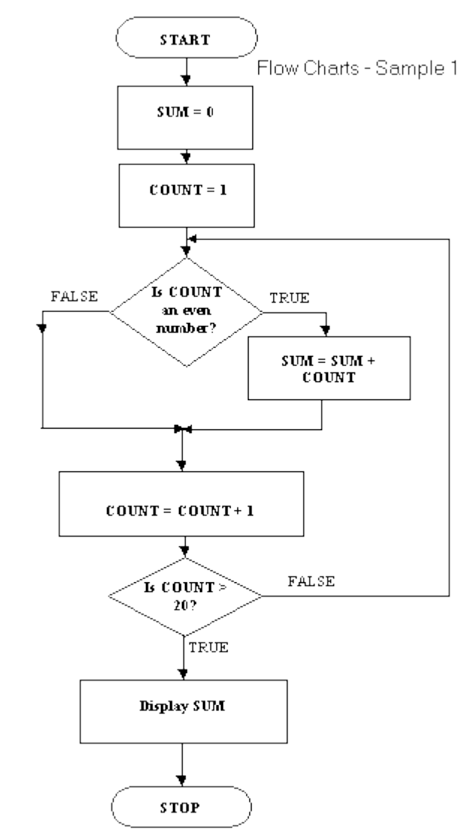

1. Write an algorithm and flowchart to read a number n and display all of its divisors.

**Algorithm:**

Step1: Start

Step2: initialize a variable i=1 and Read any number n

Step3: divide number n by i and check

if number n/i equals to zero

display the divisor is i and go to step4

else

goto step4

Step4: check

if i is less than n

increase i by 1 and go to Step3

else go to step 5

Step 5: Stop

1. Write an algorithm and flowchart which display if number is prime or not.

**Algorithm:**

Step 1: Start

Step 2: Initialize c=0,n and i=1

Step 3: Read any number n

Step 4: Repeat until i<=n else go to Step 7

Step 5: Check if n divided by i leaves remainder 0

then increase c by 1

else:

go to step 6

Step 6: increase counter i by 1 and go to step 4

Step 7: Stop